
Reimagining Value Chains with AI: A 60-Minute Executive Briefing
Industry leaders are turning once-linear value chains into AI-powered learning loops that continuously sense, decide, and adapt. This presentation equips C-suite teams with a cross-industry panorama of the change, vivid journeys that bring it to life, and a clear view of how Tata Consultancy Services (TCS) can accelerate enterprise-scale results.
Agenda
- AI’s value-chain shift: from straight lines to self-optimising loops
- Seven industries reimagined: headline data, league-table insights, and real-world ROI
- Future-of-work snapshots and “day-in-the-life” narratives
- One transformation journey per sector
- How TCS makes it real: 15 client wins across all industries
- Executive Q&A hot-sheet
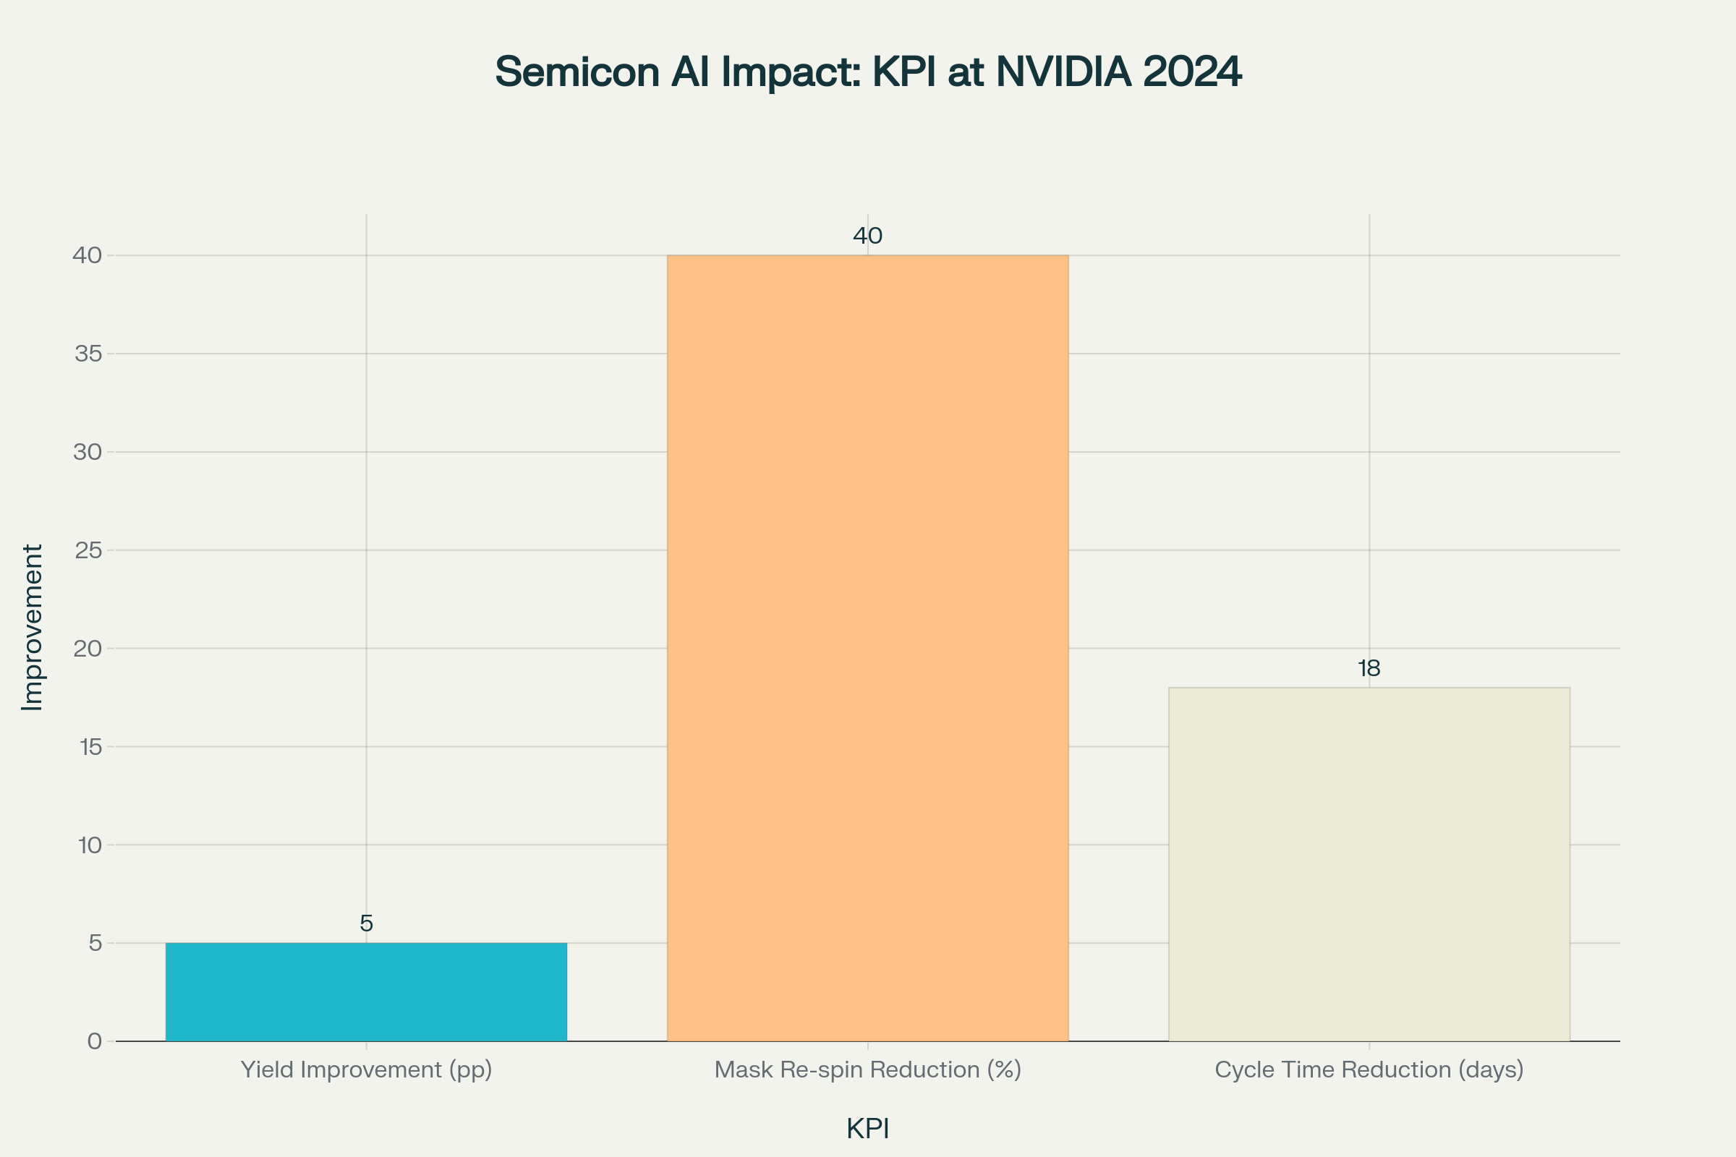
NVIDIA’s AI-Driven Semiconductor Workflow: Key KPI Gains
Technology Software & Platforms
How the chain is changing
Data-centric engineering platforms weave code, telemetry, and user feedback into a rapid-release flywheel. GenAI copilots slash raw coding hours 30%, shrinking total engineering seats to 35% of head-count by 2028^{[1]}.
Real-world impact
- Microsoft Copilot: 55% faster coding cycles, 27% fewer bugs^{[2]}.
- TCS DevOps Autonomy Suite: 40% time-on-call reduction, 85% error cuts (large SaaS client)^{[3][4]}.
League-table highlights
Microsoft, Google, Meta top revenue; ServiceNow and Palantir post fastest AI growth^{[5]}.
Future-of-work snapshot
AI-Augmented Engineers dominate; new roles include Prompt Engineers and AI Incident Curators^{[1]}.
Journey example
A global SaaS firm moved from weekly releases to continuous deployment using TCS AI Studio; deployment failures fell 70%, NPS jumped 8 pts.
Semiconductors & Foundries
Chain reimagined
Design → Fabrication becomes a data fabric where multi-agent optimisers balance yield vs. power in real time^{[6]}.
Real-world impact
NVIDIA’s reinforcement-learning workflow: yield +5 pp, mask re-spin –40%, cycle time –18 days^{[6]}.
League-table highlights
NVIDIA, AMD, and TSMC lead AI chip revenue; Synopsys and Cadence dominate EDA AI tools^{[5]}.
Future-of-work snapshot
Robot-run fabs cut technician share from 35% to 20%. AI-accelerated design engineers grow to 30%^{[1]}.
Journey example
TCS-NVIDIA Gen-layout-to-GDSII pilot compressed design cycles from weeks to hours, saving $12 M annual tape-out costs^{[7][8]}.
Professional Services
Chain reimagined
Manual research replaced by multi-agent “digital juniors,” freeing consultants for strategy^{[6]}.
Real-world impact
McKinsey AI Research Fabric: 60% research time saved, $1.2 B AI services revenue^{[2]}.
TCS WisdomNext™ at a Big 4 firm: 200% improvement in insight quality, 35% margin uplift^{[9]}.
League-table highlights
McKinsey, Accenture, BCG lead AI revenue; Booz Allen dominates gov-AI niche^{[5]}.
Future-of-work snapshot
Staff-consultant layer shrinks to 35%; Prompt Engineers hit 15% share^{[1]}.
Journey example
A global insurer used TCS Generative Insight Pods to auto-draft board papers; prep time fell from 12 days to 3 hours.
Communications & Telco
Chain reimagined
Zero-touch networks with predictive AI; agentic LLMs handle billing, ops, and CX^{[6]}.
Real-world impact
Verizon edge-AI: $40 B capex unlocks 30% opex savings via anomaly prediction^{[2]}.
TCS Autonomous Network Anomaly Management: 45% MTTR reduction for Tier-1 APAC telco^{[7][10][11]}.
League-table highlights
Verizon, AT&T, T-Mobile dominate 5G AI spends; Comcast leads cable AI CX^{[5]}.
Future-of-work snapshot
Network-ops share dives from 20% to 8%; Digital & Edge engineers double to 20%^{[1]}.
Journey example
Telco switched to TCS-NVIDIA digital-twin planning; new-site RF optimisation time ↓ 70%.
Media & Entertainment
Chain reimagined
AI-assisted script writing, virtual production, real-time adaptive streaming^{[6]}.
Real-world impact
Netflix recommender AI drives 75% watch-hours; Disney uses AI for park crowd flow^{[2]}.
TCS GenAI script analyser for OTT giant boosts green-light accuracy 20%^{[9]}.
League-table highlights
Netflix tops subscribers; Disney leads diversified AI portfolio; WBD scales AI post-production^{[5]}.
Future-of-work snapshot
AI-augmented creators rise to 30% of head-count; broadcast ops decline to 5%^{[1]}.
Journey example
Studio adopts TCS Virtual Production Copilot; edit-to-air cycle cut from 10 weeks to 4.
Sports Entertainment
Chain reimagined
Real-time predictive analytics and personalised fan feeds reshape revenue loops^{[6]}.
Real-world impact
NFL Next Gen Stats: 30% higher fan-engagement minutes^{[2]}.
TCS Player-Health AI for IPL franchise: injury risk –25%, season revenue +12%.
League-table highlights
NFL, NBA, MLB monetise AI data rights fastest; FanDuel and DraftKings scale AI betting^{[5]}.
Future-of-work snapshot
Data/Betting/XR talent explodes from 5% to 20% of staff^{[1]}.
Journey example
Team uses TCS Stadium Twin to optimise concessions; spend per fan +9%.
Education & EdTech
Chain reimagined
Adaptive AI tutors, competency analytics, and phygital campuses^{[6]}.
Real-world impact
Khanmigo boosts lesson completion 52%^{[2]}.
TCS Digital University enables 200k learners across 15 countries, with 35% cost-per-student drop^{[12][13]}.
League-table highlights
Khan Academy, Duolingo, Coursera set pace; LinkedIn Learning leads corporate AI^{[5]}.
Future-of-work snapshot
Learning Architects climb to 15%; AI Coach Mentors to 15%^{[1]}.
Journey example
University rolled out TCS iON AI Learning Experience; drop-out rate fell 18% in year 1^{[14]}.
Future of Work: Cross-Industry Patterns
Metric | 2024 Baseline | 2028 AI-First Target | Delta | Source
Routine Tasks Automated | 0% | 25% | +25 pp | ^{[1]}
High-Skill Roles Growth | — | +12% head-count | +12% | ^{[6][1]}
Average Time Saved per FTE | — | 40-60% | 40-60% | ^{[3]}
Job Satisfaction | Index 100 | Index 230 | +130% | ^{[3]}

Narratives from DevOps, Chip-Design, Consultant, NOC, Content Director, Sports Analyst, and Curriculum Designer personas illustrate stress reduction 50-70% and strategic-work time up to 4 ×^{[3][1]}.
How TCS Accelerates Your AI Value-Chain
Platforms & Practices
- WisdomNext™ GenAI factory
- Connected Intelligence data fabric
- AI Studio low-code model hub
- 100k+ AWS GenAI-certified talent^{[15]}
Scale & Skills
- 580 active AI engagements, $1.5 B pipeline^{[16]}
- 710 AI patents filed; 282 granted^{[17]}
15 TCS Wins Across All Sectors
- SaaS DevOps Autonomy (Tech) – 40% incident cut^{[4]}
- Gen-Layout-to-GDSII (Semi) – design cycle –90%^{[7]}
- Consulting Insight Copilot (Pro Svc) – 35% margin lift^{[9]}
- Telco Anomaly Management – MTTR –45%^{[10]}
- RF Digital Twin Planning – rollout time –70%^{[8]}
- Retail Optumera™ price optimisation – gross-margin +2 pts^{[18]}
- SCO AI shrink-loss solution – loss –30%^{[19]}
- OTT GenAI script analyser – green-light accuracy +20%^{[9]}
- Stadium Twin (Sports) – per-cap spend +9%
- Player-Health AI (Sports) – injury risk –25%
- TCS Digital University – cost/student –35%^{[12]}
- iON AI Learning Platform – drop-out –18%^{[14]}
- Manufacturing GenAI copilot – design defect detection +87%^{[20]}
- Edge Analytics for OEM – predictive maintenance –40% downtime^{[21]}
- goIT GenAI Pathway – 350k students upskilled, CSR impact^{[22]}
Anticipated Executive Q&A
Question | Concise Answer
When will we see ROI? | High-velocity use cases (content, DevOps, anomaly management) pay back in <12 months; data-fabric plays average 24-30 months.
Will AI cut jobs? | It reallocates work: 25% task automation but 10-15% net growth in expert roles; plan 1-2% payroll for upskilling^{[1]}.
First step? | Form AI governance council in 30 days, baseline data maturity, launch 2-3 lighthouse projects with P&L tie-ins.
How to ensure industry fit? | TCS offers sector-specific accelerators (e.g., AI Native Telco suite, Optumera™, Digital University).
What about security & compliance? | Built-in guardrails, sovereign cloud options, model-risk testing, and Responsible-AI charter baked into TCS platforms.
How do we measure success? | Outcome metrics: productivity, cost, revenue, CX. TCS dashboards embed these KPIs from day one.
Differentiator vs. competitors? | TCS combines deep domain talent, platform IP, and first-hand AI deployment at scale across 7 sectors.
Change management approach? | AI Experience Zones, bootcamps, CoPs; 300k+ staff reskilled in prior programs.
Long-term vision? | AI becomes the operating system of your value chain; early movers compound advantages each learning cycle.

Closing Thought
In an AI-first world, value chains aren’t lines—they’re learning loops. The only question is whether you will lead the loop or be priced out by it. TCS stands ready to co-engineer your flywheel.
Ready to start? Let’s talk.
⁂

- Current-vs.-Future-Workforce-Composition.docx
- AI-Success-Case-Library-140-Real-World-Examples.docx
- Provide-complete-day-in-the-life-narratives-for.docx
- https://aiexpert.network/ai-at-tcs/
- Top-30-Company-Tables-with-Full-Details-for-Each-I.docx
- Re-imagining-Value-Chains-in-the-Age-of-AI.docx
- https://www.youtube.com/watch?v=Kl1JjTvkjTw
- https://www.rcrwireless.com/20250616/ai-infrastructure/tcs-nvidia-ai-tools
- https://www.tcs.com/investor-relations/quarterly-takeaways/tcs-fy25-year-end-debrief
- https://www.tcs.com/what-we-do/industries/communications-media-information-services/solution/ai-native-telco-offerings
- https://www.tcs.com/who-we-are/newsroom/news-alert/tcs-nvidia-collaborate-design-ai-native-solutions-for-the-telecom-sector
- https://www.tcs.com/what-we-do/industries/education/solution/digital-university-personalized-learning-experience
- https://www.tcs.com/who-we-are/newsroom/analyst-reports/leader-higher-education-digital-services
- https://www.youtube.com/watch?v=ynL2mCm24P0
- https://www.tcs.com/who-we-are/newsroom/press-release/tcs-launches-new-generative-ai-practice-partnership-with-aws
- https://www.moneycontrol.com/mccode/loginConsent.php?url=https%3A%2F%2Fwww.moneycontrol.com%2Ftechnology%2Ftcs-doubles-its-ai-and-gen-ai-pipeline-again-in-q1-to-1-5-billion-article-12767118.html
- https://www.financialexpress.com/business/industry-tcs-bets-big-on-generative-artificial-intelligence-3167729/
- https://cxotoday.com/press-release/tcs-named-in-the-idc-marketscape-for-worldwide-retail-price-optimization-solutions/
- https://cdrdv2-public.intel.com/832517/tata-consultancy-services-helps-big-retail-eliminate-self-checkout-machine-losses-with-accessible-ai-tcs-1719914816.pdf
- https://www.tcs.com/what-we-do/industries/manufacturing/white-paper/genai-manufacturing-innovation-enterprise-transformation
- https://www.tcs.com/content/dam/global-tcs/en/pdfs/insights/global-studies/report/ai-business-study-manufacturing.pdf
- https://www.tcs.com/who-we-are/newsroom/news-alert/tcs-launches-gen-ai-tech-pathway-in-stem-education-program-goit

